**Program 1**

public class Command_Input

{

public static void main(String[] args)

{

System.out.println("Enter two decimal values:");

double a=Double.parseDouble(args[0]);

double b=Double.parseDouble(args[1]);

double s = a + b;

System.out.println("First: " + a);

System.out.println("Second: " + b);

System.out.println("Sum: " + s);

}

}

**Output:**

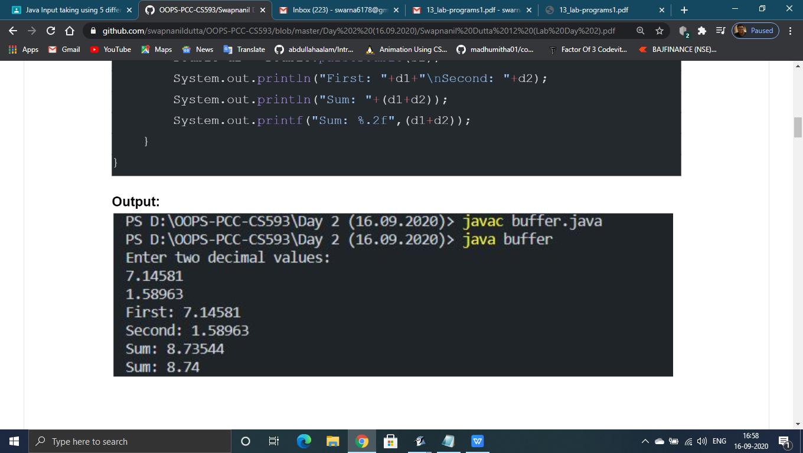

**Program 2**

import java.io.*;

public class Buffer_Input

{

public static void main(String args[]) throws IOException

{

InputStreamReader s=new InputStreamReader(System.in);

BufferedReader in=new BufferedReader(s);

System.out.println("Enter 2 decimals :");

String s1=in.readLine();

String s2=in.readLine();

double a=Double.parseDouble(s1);

double b=Double.parseDouble(s2);

double p = a * b;

double sum = a + b;

System.out.println("Sum : " + sum + "\tProduct : " + p);

}

}

**Output:**

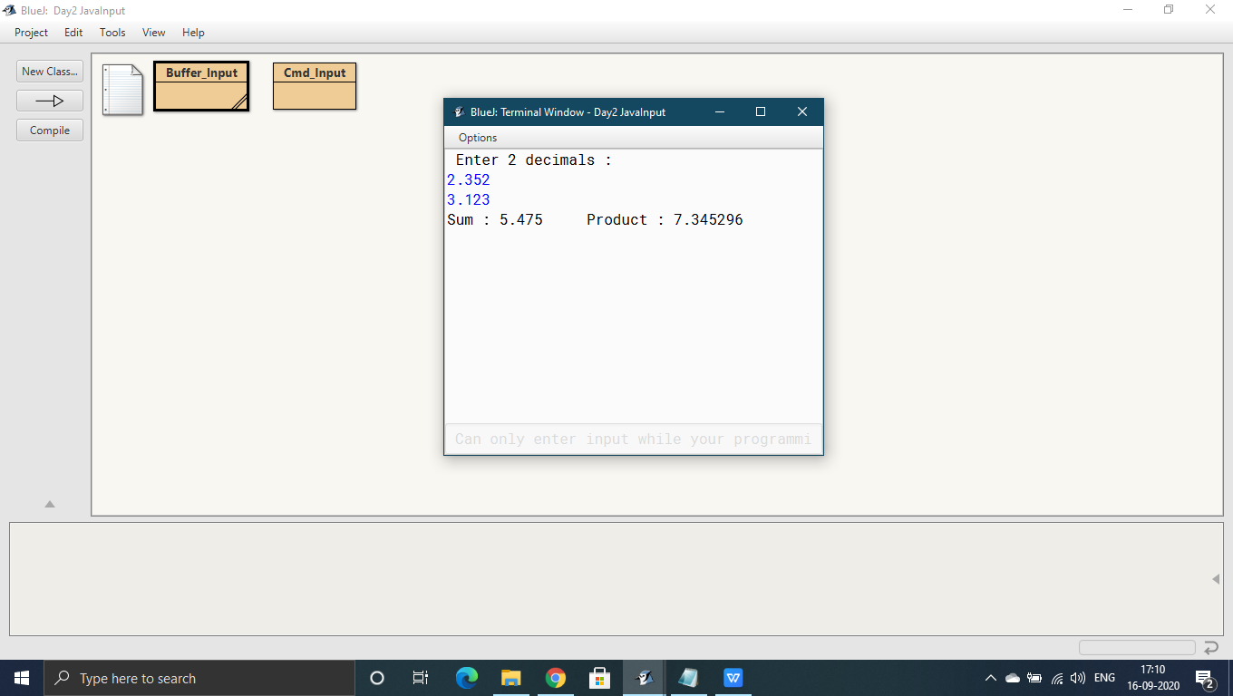

**Program 3**

import java.io.Console;

public class Console_Input

{

public static void main(String args[])

{

Console in=System.console();

System.out.println("Enter two decimal values:");

double a = Double.parseDouble(in.readLine());

double b = Double.parseDouble(in.readLine());

double s = a + b;

double p = a * b;

System.out.println("Sum = " + s + "\nProduct = " + p);

}

}

**Output:**

Enter two decimal values:

2.1

3.2

Sum = 5.3

Product = 6.72

**Program 4**

import java.io.*;

public class Basic_Input

{

public static void main(String[] args) throws IOException

{

char ch;

String str = "";

System.out.println("Enter a decimal value {press * to quit} :");

while((ch = (char)System.in.read())!='*')

str = str + ch;

double n=Double.parseDouble(str);

System.out.println("Number is " + n);

}

}

**Output:**

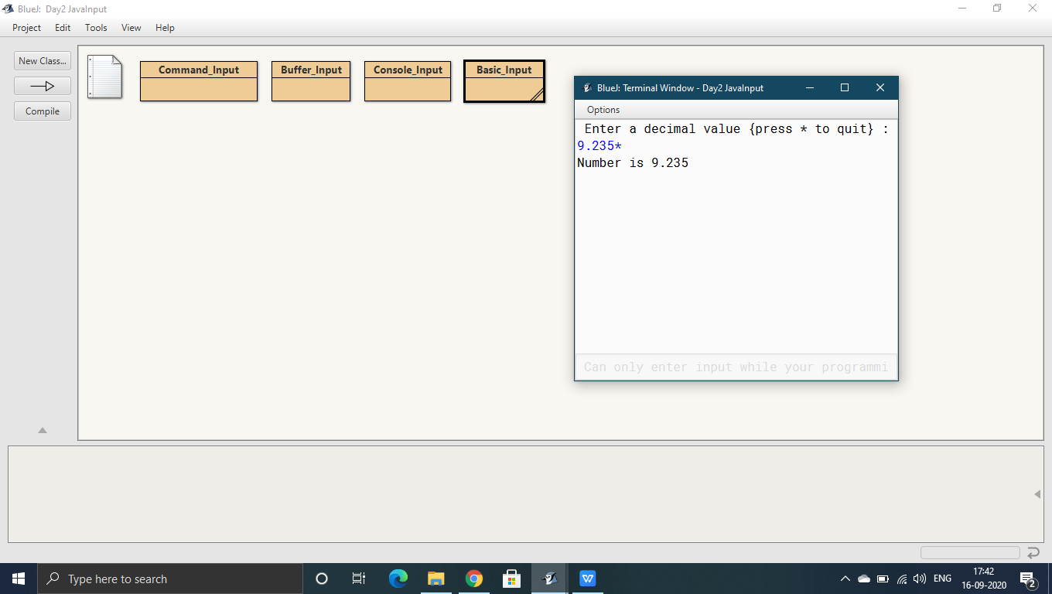

**Program 5**

import java.util.*;

class Scan_Input

{

public static void main()

{

Scanner sc = new Scanner(System.in);

Scanner inp = new Scanner(System.in);

System.out.println("Enter Name and age : ");

String str = inp.nextLine();

int age = sc.nextInt();

System.out.println("Name = " + str);

System.out.println("Age = " + age);

}

}

**Output:**

